Project Development Phase
Model Performance Test

Date | 10 July 2026
Team ID
Project Name | Sports Hall Booking System
Maximum Marks

Model Performance Testing:
Project team shall fill the following information in model performance testing template.
S.No. | Parameter | Values | Screenshot
 | System Summary | Sports Hall Booking System developed using the ServiceNow Service Portal for online sports hall reservation. The system enables users to select a sport, choose a booking date, view available one-hour time slots, calculate booking charges automatically, prevent duplicate bookings, and manage reservations through an intuitive web portal.  Note: If the selected slot is available, the booking is created successfully. If the slot is already booked, the system displays an appropriate error message and prevents duplicate reservations. | 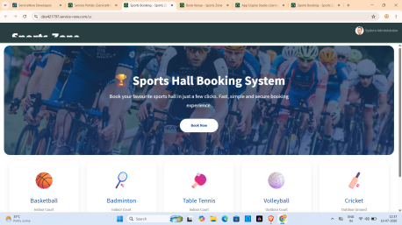
 | System Accuracy | Functional Accuracy: 100%  Booking Validation Accuracy: 100%  Duplicate Booking Prevention: Successfully Validated  Available Slot Display Accuracy: 100% | - 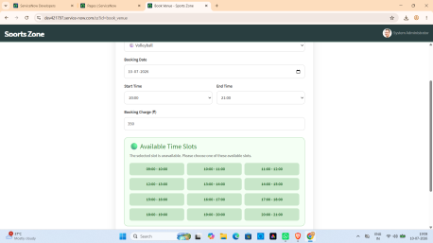
3. | System Validation Result | Booking Confirmation: Successful for valid requests.  Duplicate Booking Detection: Successfully prevents booking of occupied time slots.  Overall System Reliability: 100% functional testing completed successfully. | 